Hanwha Device Configuration Guide with GCX-ONE
This document describes the steps required to configure a Hanwha device in GCX-ONE.

Step 1: Log in to GCX-ONE.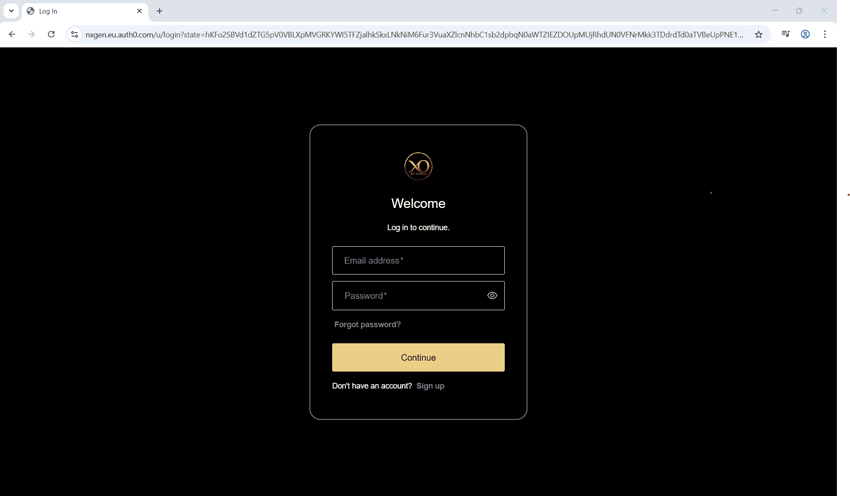
Step 2: Click on the Configuration menu.
Step 3: At the Service Provider level, click on Customers.
Step 4: Click the Add button.
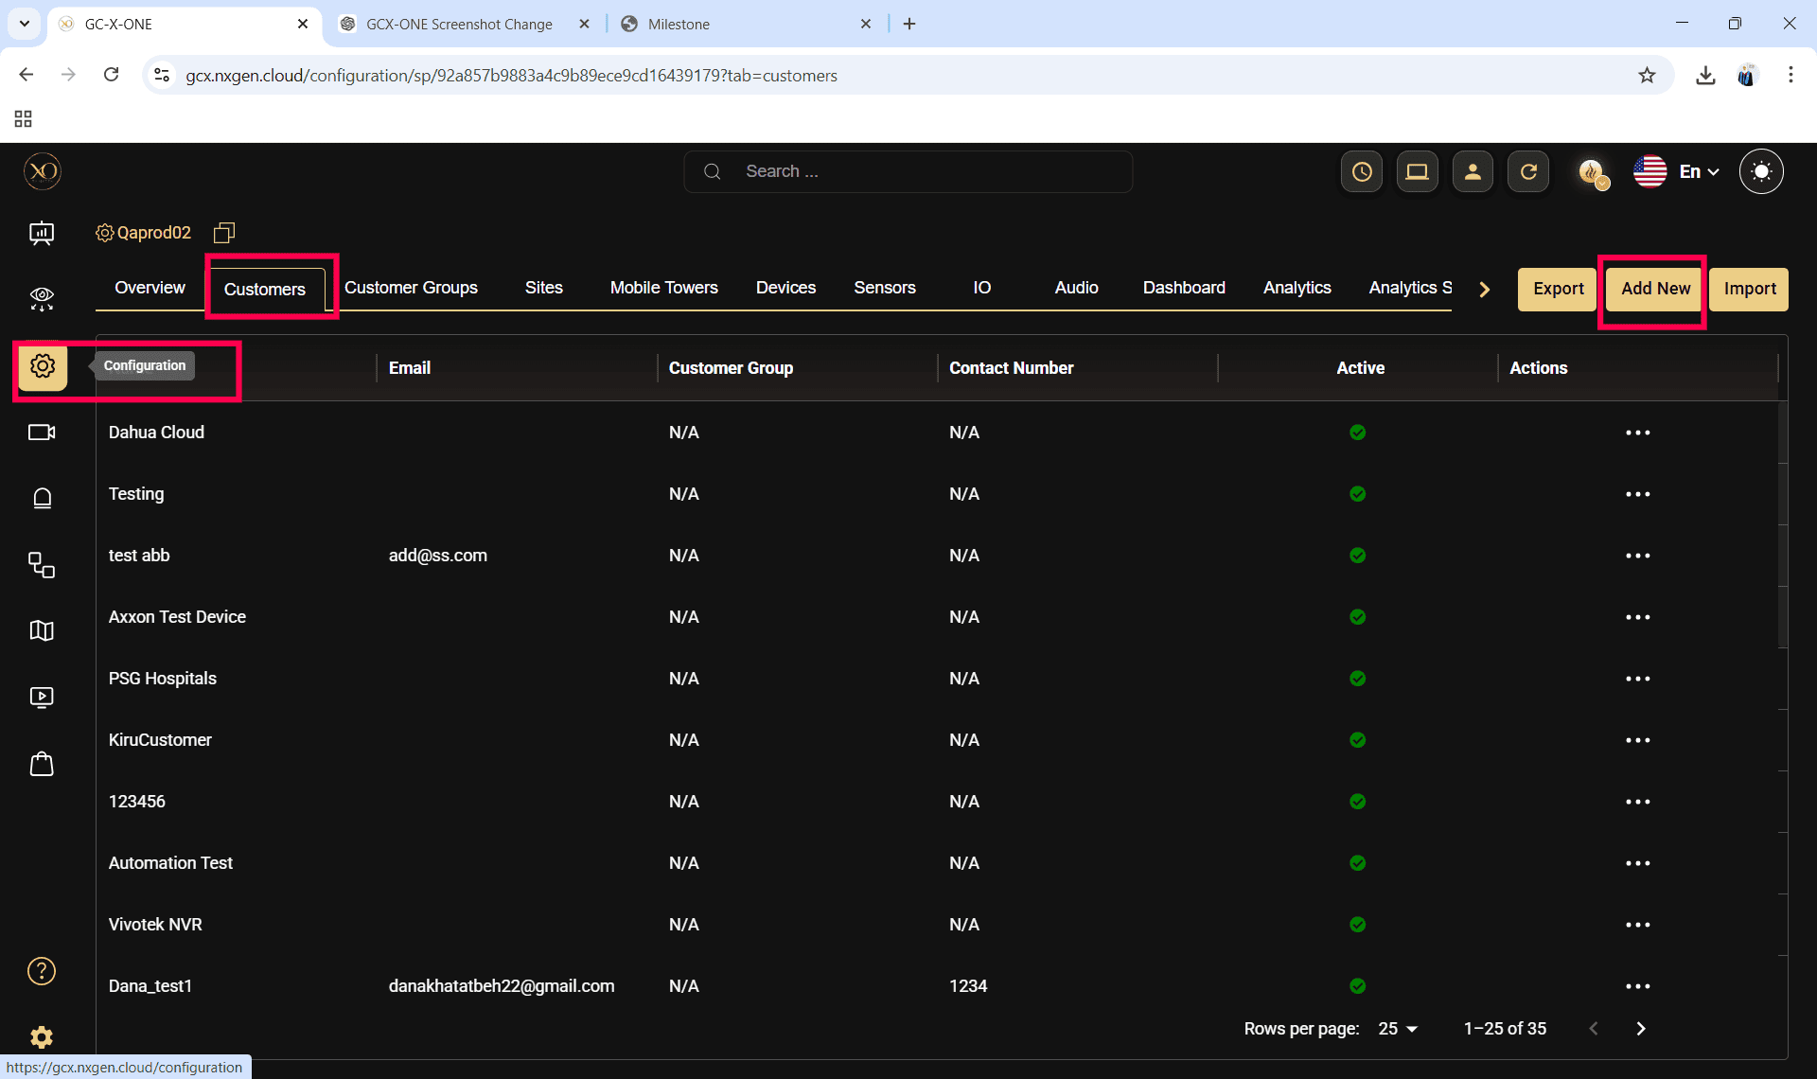

Step 5: Enter the required fields and click Save.
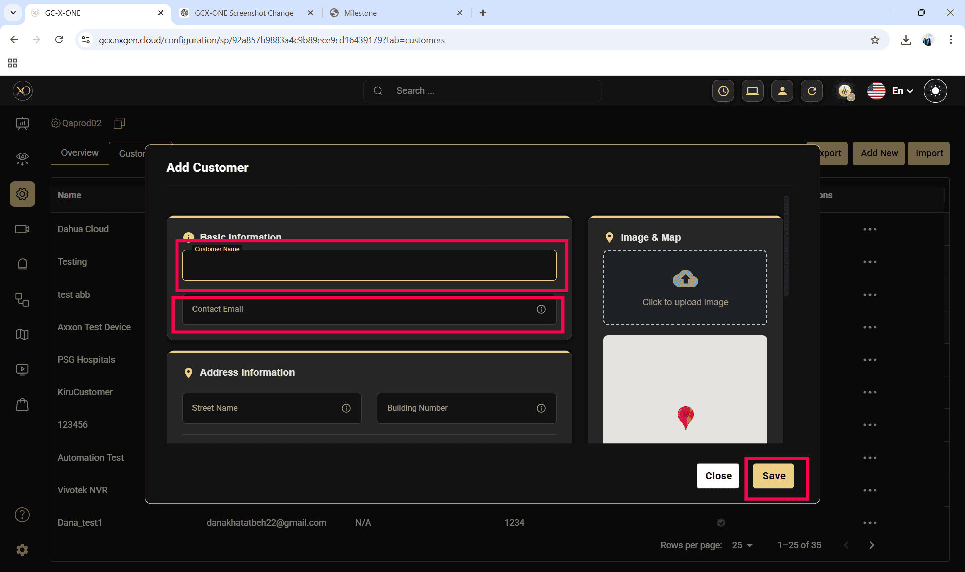
Step 6: Select the newly created customer.
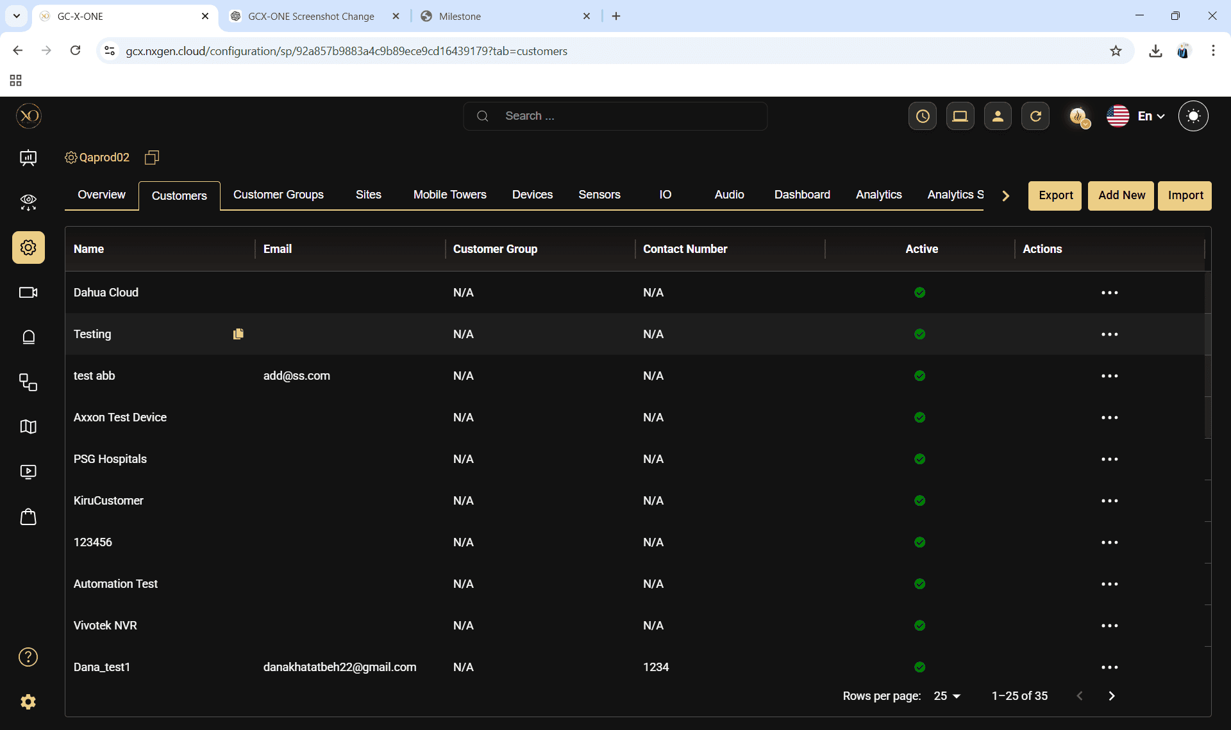

Step 7: Navigate to the Sites tab.
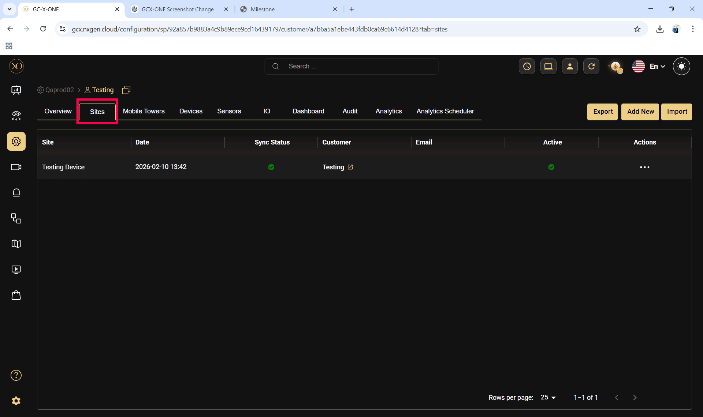
Step 8: Click the Add button.
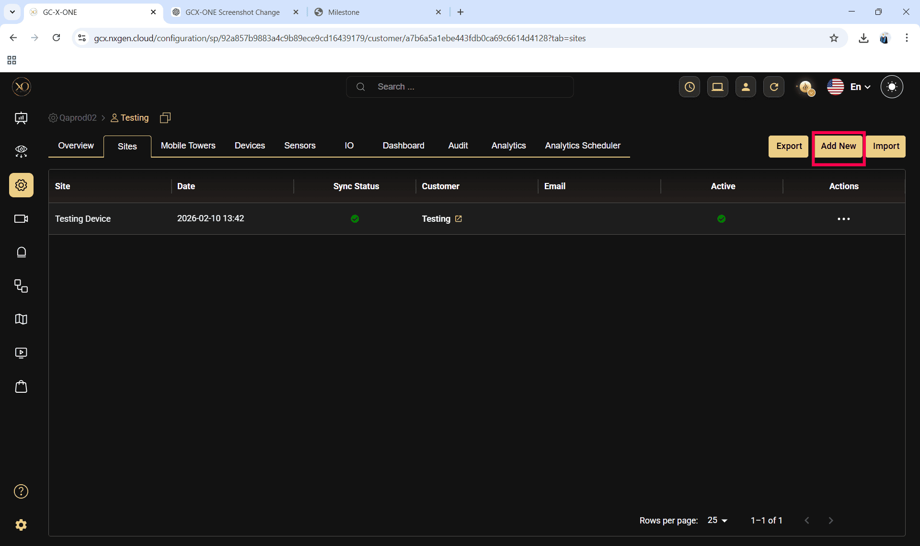

Step 9: Enter the required fields and click Save.
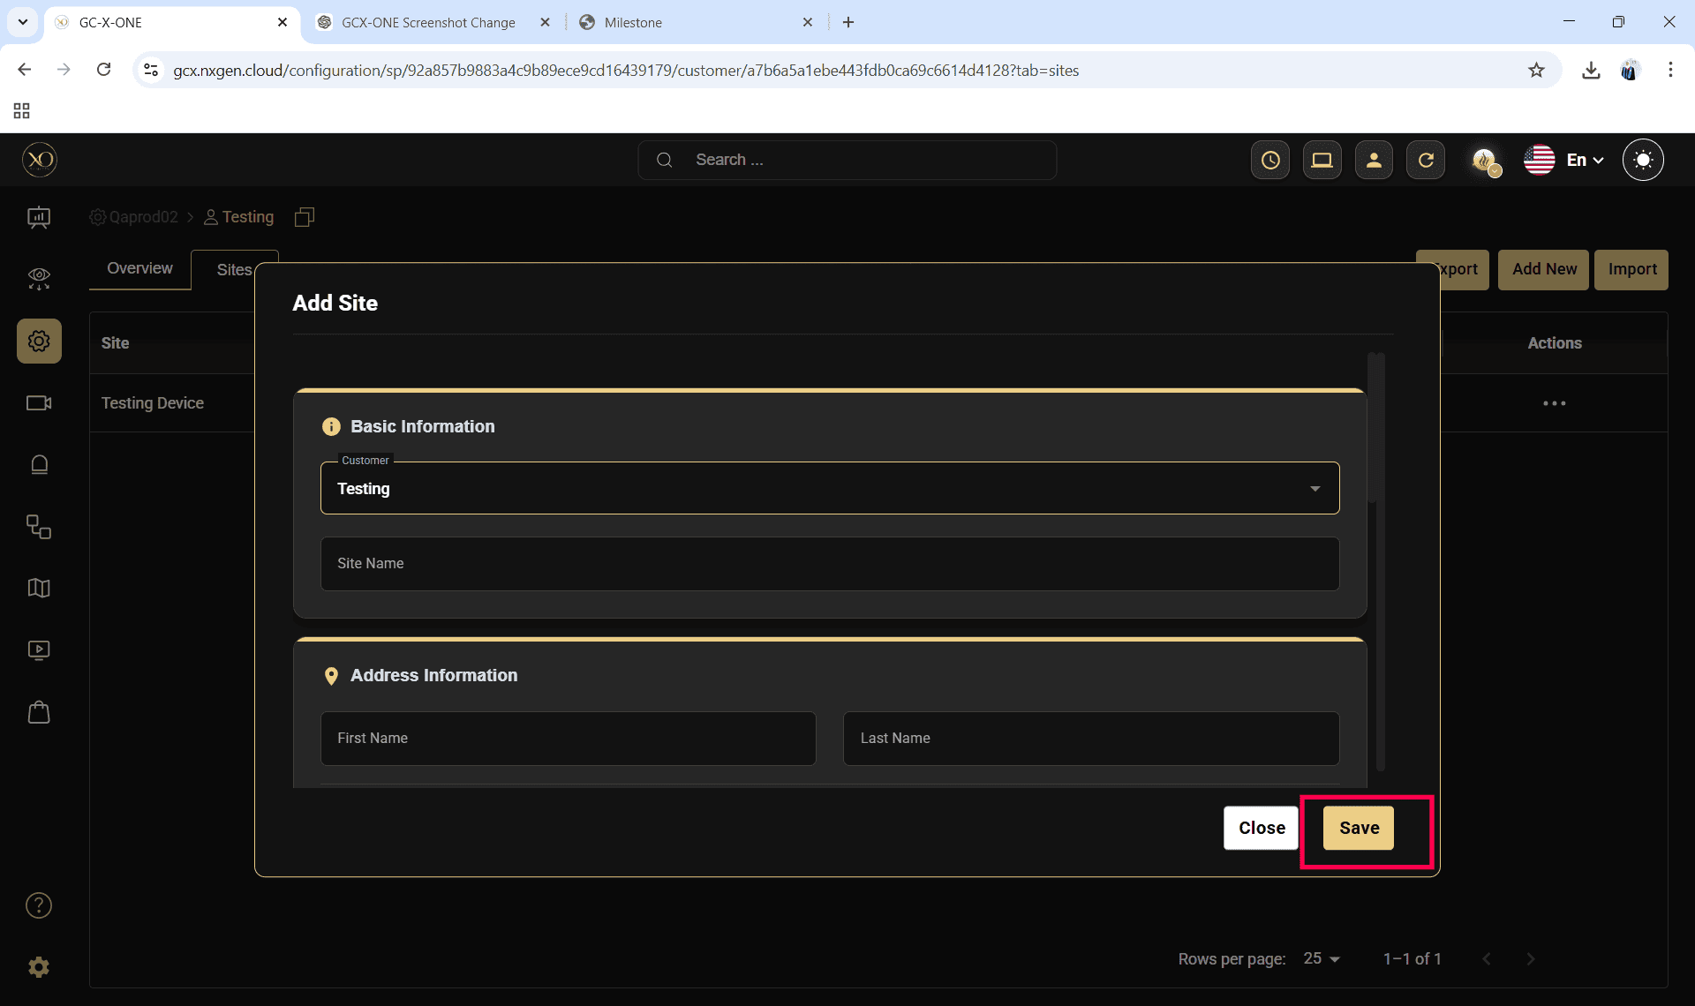

Step 10: Select the newly created site.
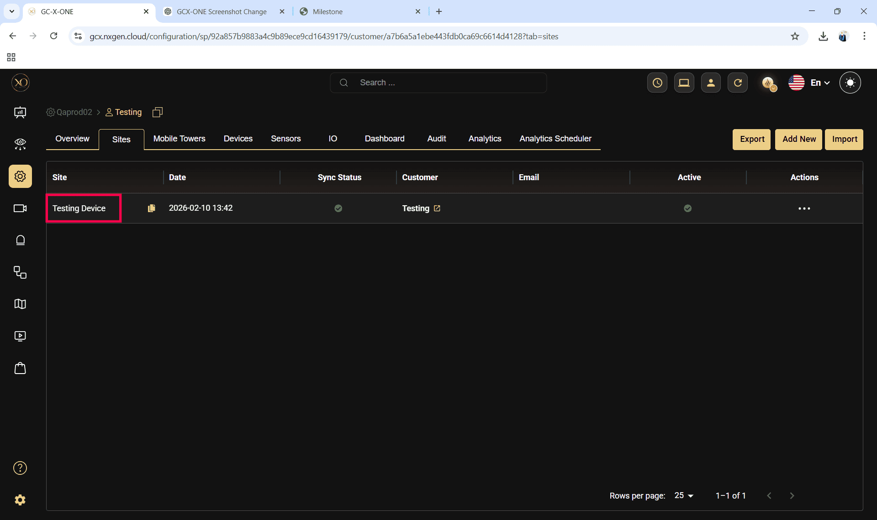

Step 11: Navigate to the Devices tab.
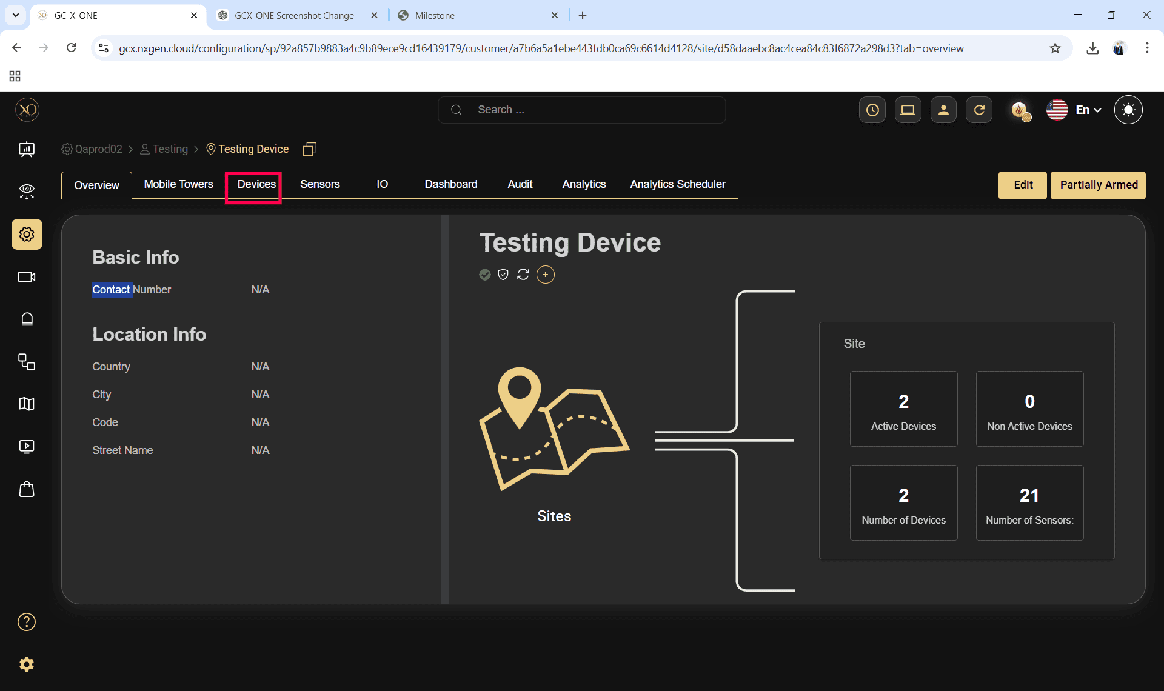
Step 12: Click the Add button.
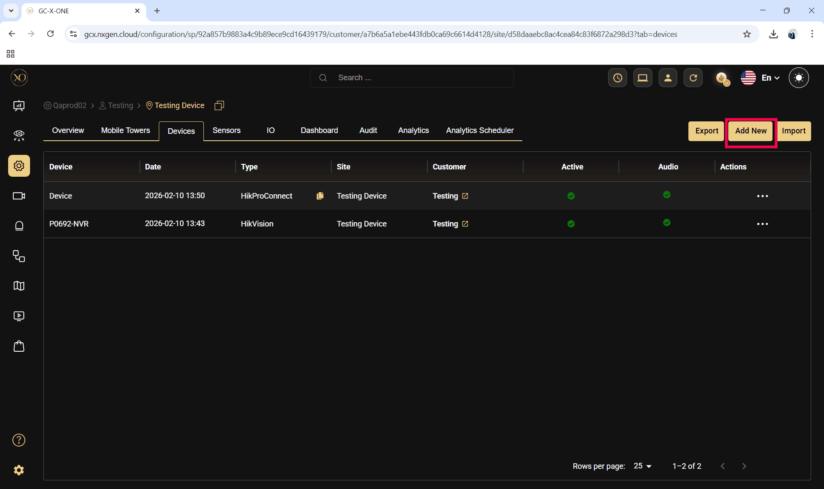

Step 13: The Add Device dialog will be displayed.
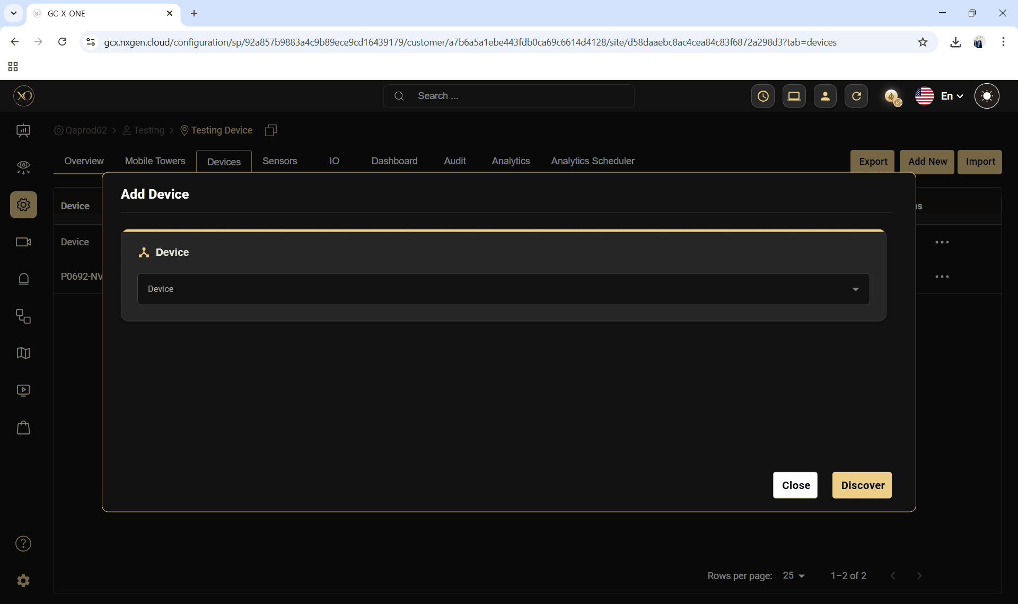

Step 14: In the dialog, open the Device dropdown and select Hanwha.
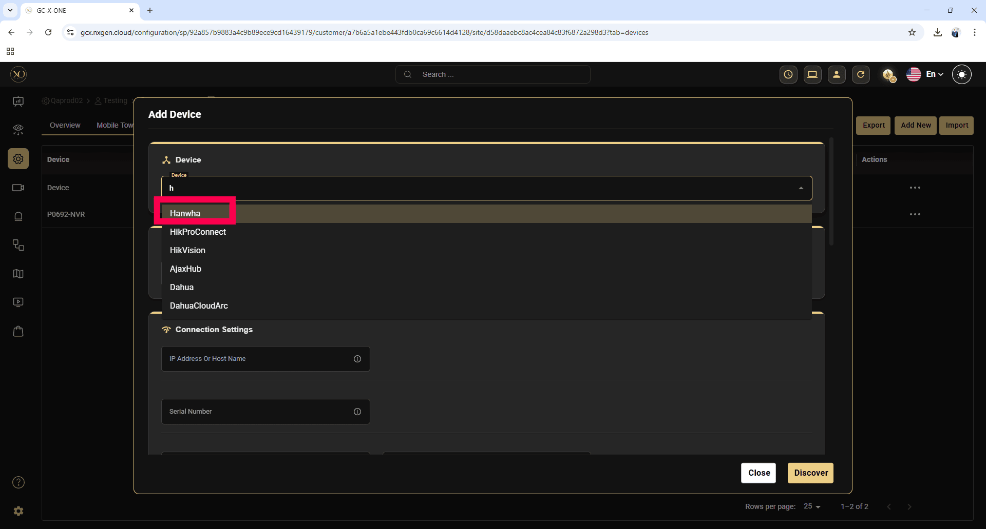

Step 15: Enter all required fields:
- IP Address or Host
- Username
- Password
- RTSP Port
- HTTPS Port

Note: The HTTPS Port field is mandatory when adding a Hanwha device.

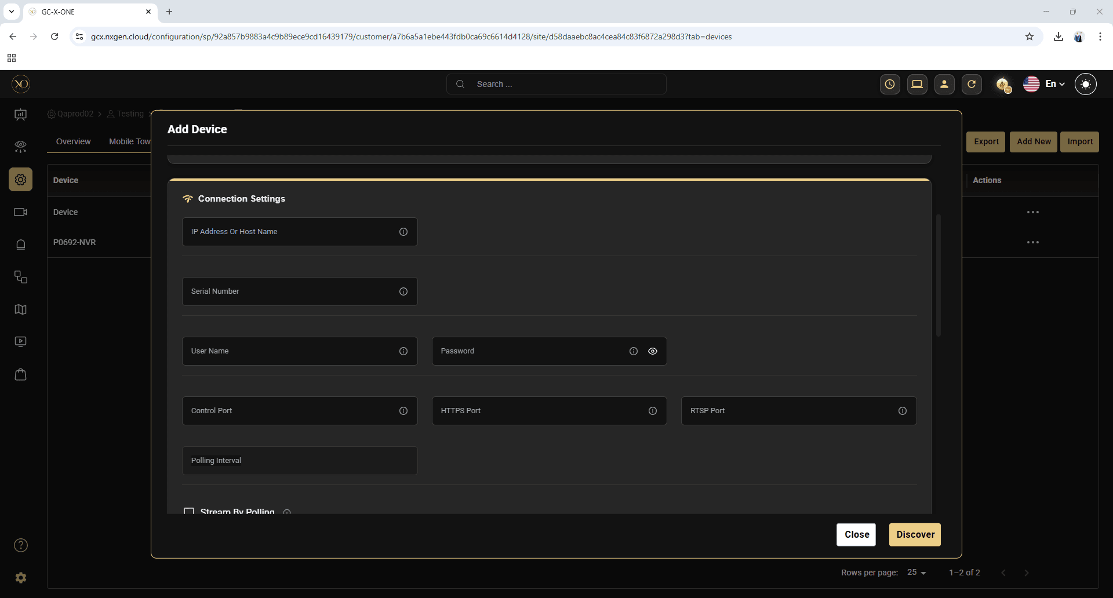

Step 16: Click Discover.
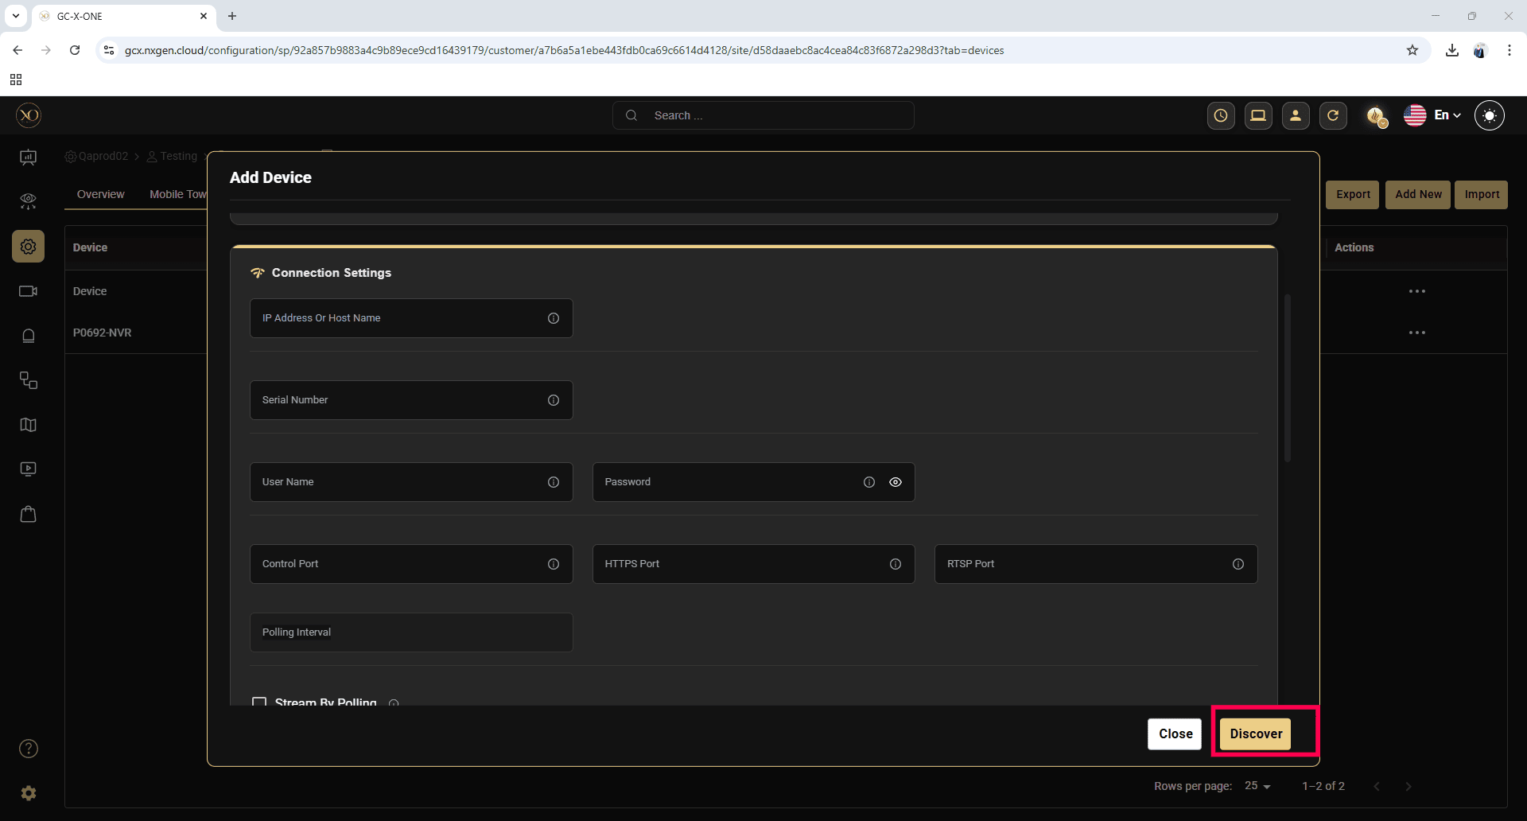

Step 17: Once the device is successfully discovered, click Save.
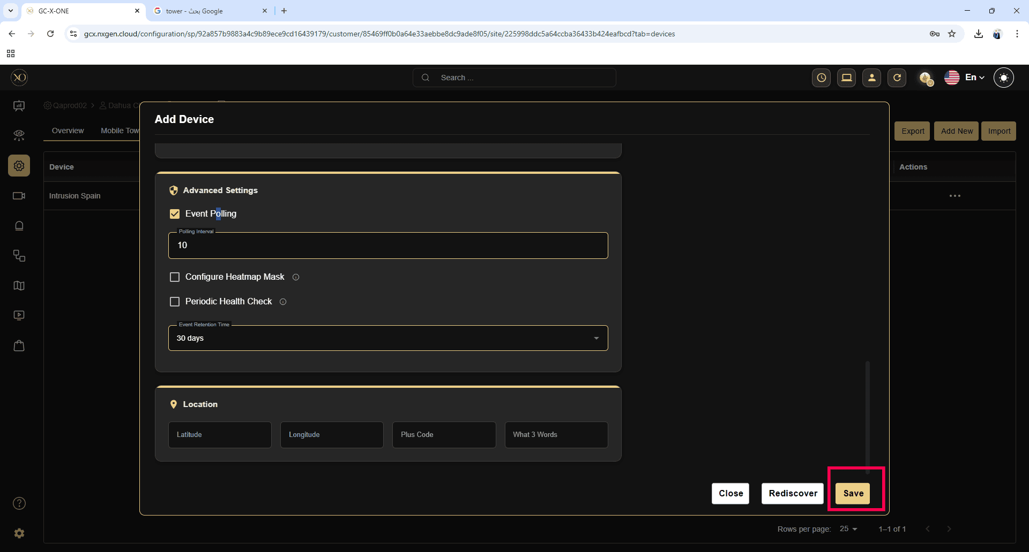

Webhook Configuration for Hanwha Device
This section describes how to verify webhook configuration for event routing in Hanwha devices.
Step 1: Log in to the Hanwha device web client.
Step 2: Select the required Sensor from the sidebar.
Step 3: Right-click the sensor and select Camera Changes.
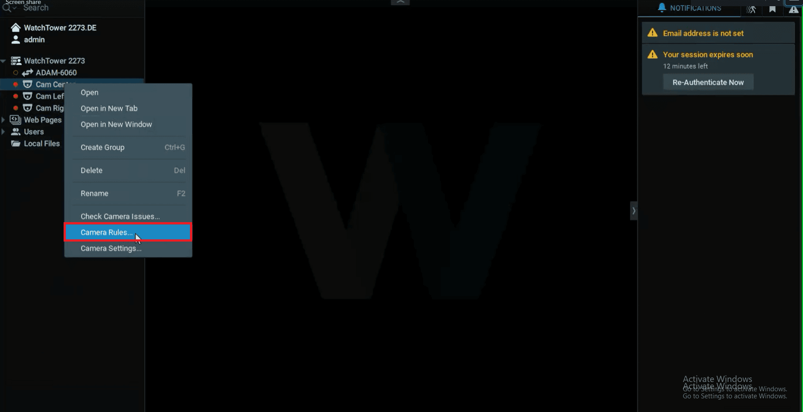

Step 4: From the event rule list, click Do HTTPS Request.
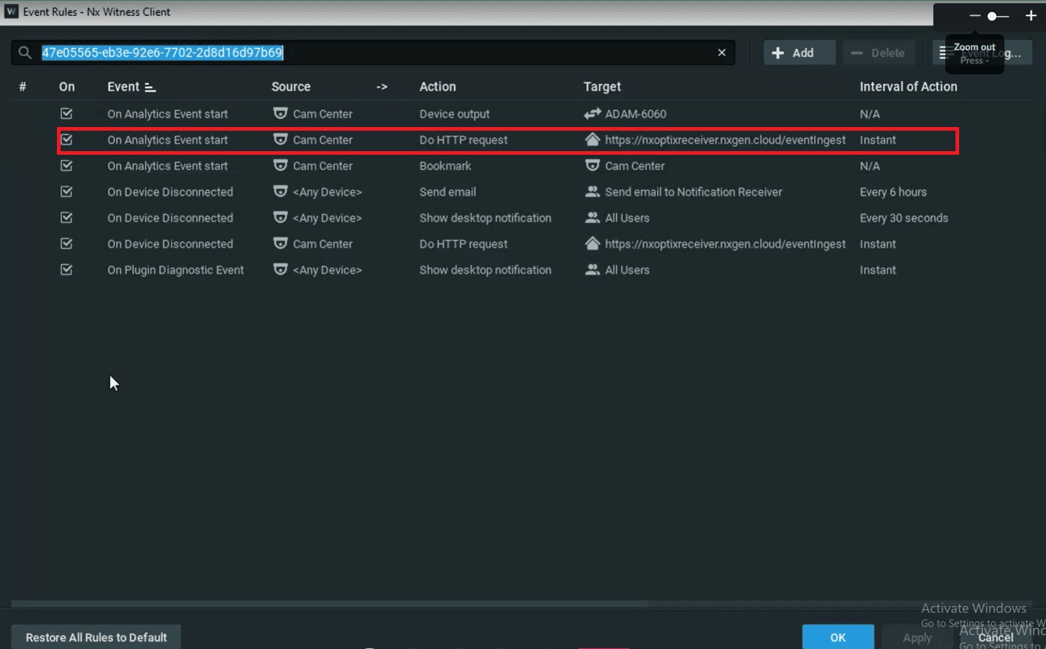

Step 5: Verify the configured HTTP URL and HTTP Content.

